Overview of the 14th NEAR Subcommittee on Environment

The 14th NEAR Subcommittee on Environment was held at Toyama Prefecture on Thursday, November 14.
At this meeting, there were activity reports ・ suggestions according to the「2016 Toyama Declaration＊」and, at the same time, Toyama Prefecture was elected as a next coordinator.
There followed six suggestions for individual projects in 2020 including three from Toyama Prefecture, two from Chungcheongnam-do Province, South Korea, and one from Tomsk Region, Russia, and agreements of attending regional governments.
1. Purpose
The goal of this meeting is to pursue the smooth implementation of individual projects being carried out by NEAR Regional Governments on environmental preservation, to promote information sharing, and to carry out environmental preservation measures.

2. Date ・ Venue
・ November 14, 2019 (Thu.) from 09:30 to 16:00
- Oaks Canal Park Hotel Toyama (11-1, Ushijima, Toyama City, Toyama Prefecture)

3. Organizer

Toyama Prefecture, The Association of North East Asia Regional Governments (NEAR)
(The NPEC Public Foundation Corporation is commissioned by Toyama Prefecture to manage the operations of the NEAR Subcommittee on Environment.)

4. Participants
7 Regional Governments from 3 countries
・China (1) : Heilongjiang Province ・Japan (2) : Yamagata Prefecture, Toyama Prefecture
・Russia (2) : Primorsky Territory, Khabarovsk Territory
(Observer)
・China (1) : Liaoning Province ・Japan (1) : Saga Prefecture

5. Results
( 1 ) Election of the next coordinator of Regional Government (Consultation)
Toyama Prefecture was elected as the next coordinator of Regional Government. (Term : 2 years)
( 2 ) Report on the implementation of individual projects in 2019 (Report)
There were reports by regional governments on the implementation status of individual projects in 2019
Name of Individual Projects in 2019 | Proposing Regional Government
Northeast Asia Youth Environment Activity Leader Development Project | Khabarovsk Territory, Russia  Toyama Prefecture
Learning・Development Project on Outbreak Suppression of Driftage | Toyama Prefecture
Northeast Asia Region Environmental Poster Exhibition | Toyama Prefecture
Investigation on Ocean Biology | Toyama Prefecture
Blue Carbon Youth Environmental Educational Experience Program on the Subject of Shellfish | Chungcheongnam-do Province, South Korea
Photo Contest 「Eco-selfie－Environmental Preservation with selfie」 | Tomsk Region, Russia

( 3 ) Proposal Status of Individual Projects in, activity plans of the Subcommittee
on Environment (Consultation)
There were six suggestions for individual projects in 2020 which were implemented with the agreement of participating Regional Governments.
In addition, as a matter of consideration for individual projects, the decision to make efforts to realize SDGs, consider climate change measures and marine plastic garbage measures according to global trends surrounding environmental issues. Furthermore, an agreement was made to undertake specific activities on environmental preservation in Northeast Asian in accordance with the「2016 Toyama Declaration＊」.
Name of Individual Projects in 2019 | Proposing Regional Government
Northeast Asia Youth Environment Activity Leader Development Project | Khabarovsk Territory, Russia  Toyama Prefecture
Learning・Development Project on Outbreak Suppression of Driftage | Toyama Prefecture
Northeast Asia Region Environmental Poster Exhibition | Toyama Prefecture
Investigation on Ocean Biology | Toyama Prefecture
Blue Carbon Youth Environmental Educational Experience Program on the Subject of Shellfish | Chungcheongnam-do Province, South Korea
Photo Contest 「Eco-selfie－Environmental Preservation with selfie」 | Tomsk Region, Russia

( 4 ) Information exchange on the advanced environmental policy of each regional government
There were presentations on advanced environmental measures and active information sharing by Liaoning Province and Russian local areas.
Title of Presentation | Presentation Group
Activity on air pollution prevention・management of Liaoning Province | Liaoning Province, China
In terms of environmental preservation policy of Primorsky Territory | Primorsky Territory, Russia

( 5 ) Others
・Toyama Prefecture introduced environmental preservation activity of prefectural mobilization including an individual project of the Subcommittee on Environment at the world general assembly of「The Most Beautiful Bay Clubs around the World 」held in Toyama Prefecture on October, 2019 and this was included in the「Bay Club Toyama Declaration」.
・Participants toured Echota County the next day, October 15.

【Meeting Images】
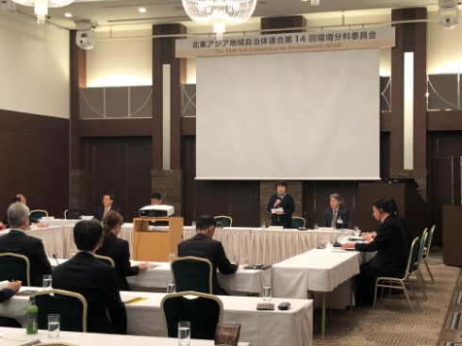 | 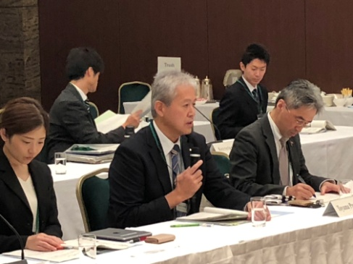 | 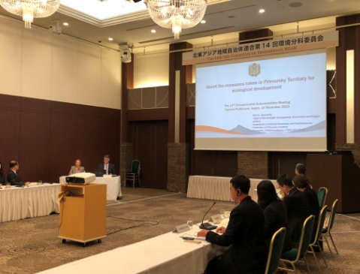

＊ 「2016 Toyama Declaration」: the meeting of environmental experts of Northeast Asian regional governments in 2016
Toyama Prefecture held the「2016 Environmental Experts Meeting of Northeast Asian Regional Governments in Toyama」in which regional governments from China, Japan, Russia, and South Korea participated taking the opportunity to meet the G7 Toyama environmental minister. At the meeting, the 「2016 Toyama Declaration」was adopted for environmental preservation to pass on a rich natural environment in Northeast Asian regions to the next generation.
At the declaration, concrete activity directions were included such as the「Active Contribution on Global Environmental Issues」,「Pursuing Citizen’s Cooperation and Environmental Education」, and「Promoting International Dialogue」.

